SOFTWARE ENGNEERING

FILNAL PROJECT

(Pets Clinic Management System)

Team members:

1. عبدالرحمن محمد طلعت مصطفى
2. عبدالفتاح احمد عبدالفتاح سالم
3. عبدالله احمد عبدالله بغدادى
4. عبدالرحمن كرم محمود ابوالخير
5. عبدالله هشام جمعة خضر
6. سلمى احمد عبدالقادر عبدالعزيز

Contents

**1.** **Introduction: -** 3

**2.** **Problem Definition: -** 3

**3. System objectives: - 4**

**4. Project Overview:-**

**5. Project Startup:-……………………………………………………………………………………………………………………………**

**4.** **SYSTEM REQUIREMENT SPECIFICATION: -** 4

1) Functional requirments 4

• Purpose**:-** 4

• Scope: - 4

**2)** **Non-functional requirements** 4

**3)** **Software and hardware requirements** 5

**5.** **Project overview** 5

6. USE CASE DIAGRAM 6

**7.** ACTIVITY DIGRAM 7

8. STATE DIAGRAM 8

9. CLASS DIAGRAM 9

10. Sequence diagrams 10

11. Dataflow diagram (DFD) 13

12. System graphic user interface 15

13. Conclusion: - 17

# **Introduction: -**

* The goal of the system is to create a tool for managing the workflow of a veterinarian. There was a need for a application that would keep track of patients, appointments, procedures and medication. we aim to provide a robust system that addresses the challenges faced by pet clinics, enhancing overall efficiency and patient care.
* Pets clinics offered various kind of services to pets such as treatments, vaccination and deworming, surgery cases, grooming, hostel services and boarding.

# **Problem Definition: -**

* Traditional methods of running pet clinics often involve manual record keeping. The receptionist must fill out a pet registration form. As for pets that have previously visited the clinic, the receptionist will search for them in the paper records in the name of their owner. This method will take a lot of time and effort to register and search for animals, as well as the possibility of lost or damaged records, and overlapping schedules.
* So, this system helps clinic to keep records of pet registration, treatment histories, setting up appointments and list down prescription to pets.

pets clinic is a desktop application that helps to store and manage information and procedures that vets have to deal with every day and keep track of the patients. The pages are made by Java, the database is handled by MySQL.

# **System Objectives: -**

* The Pets Clinic Management System aims to replace the traditional paper-based manual system utilized by individuals who manually record and maintain information through hardcopies or physical files.
* Make the process of booking an appointment for the patient more easier and faster
* Make the process of managing the appointment to the clinic employees more easier and reduce its conflict
* Improving the reporting system, streamlining the data extraction process, and providing clinic staff with an efficient method for information maintenance and updates.

# **4.Project Overview**

## 4.1 Project Scope

| **Project Includes** |
| --- |
| Veterinarians who specialize in treating animals. |
| Receptionists responsible for receiving animals. |
| Animals receiving medical treatment. |
| System administrator managing the system. |
| Data of the doctors, receptionists, Administrator, and animals. |

| **Project Excludes** |
| --- |
| Web application |
| Android application |
| Treating animals remotely |
| Buying and selling animals |

## 4.2 Assumptions

| **Assumptions** |
| --- |
| Our team will complete milestones according to schedule |
| Commitment with a specific maximum time 60 days |
| Commitment with a specific cost 75000$ |
| Our team are capable of completing necessary tasks |
| Costs won’t change throughout the course of the project |

## 4.3 Constraints

| **Constraints** |
| --- |
| Time : will not exceed 60 days |
| Cost : a specific cost 75000$ |
| Scope |
| Risks |
| Organizational Structure |

# 5.Risks

| **Name** | **Action Plan** |
| --- | --- |
| Hardware failure | Schedule preventive maintenance.  Back up critical data regularly. |
| Software failure | Check logs for details.  Try restarting the software or system.  seek assistance from a technical support team. |
| Network failure | Investigate service outages and contact your provider.  Contact IT support if issues persist. |
| Power failure | Providing generators in the event of a power outage.  Take a periodic backup of the system. |
| Cost | An excess budget is created in anticipation of any increase in maintenance or project requirements. |
| Time | Determine additional time in anticipation of any external circumstance that delays the development process. |

# **5.Project Startup**

## 5.1 Project Life Cycle

|  |  |  |
| --- | --- | --- |
| Phase | Activities | Sequence |
| Planning | * Define project problem and scope. * Define the schedule of the project. * Determine staff of the project. | Phase 1 |
| Analysis | * Gathering requirements * Collect information about the project. * Determine the functions of the project. | Phase 2 |
| Design | Design: database, UI/UX, GUI, integrated Network and Software components. | Phase 3 |
| Developing | Implement the code of the project. | Phase 4 |
| Testing | Test the system after coding phase. | Phase 5 |
| Verification | * Training the user on how to use the project. * document the system. * install the system. | Phase 6 |
| Maintenance | * Provide phone support. * Implement changes and any new requirements. | Phase 7 |

|  |  |  |
| --- | --- | --- |
| Activity | Symbol | Dependency |
| Define project problem and scope. | **1** | **-------------** |
| Define the schedule of the project. | **2** | **2 🡪 1** |
| Determine staff of the project. | **3** | **3 🡪 1** |
| Gathering requirements | **4** | **4 🡪 2** |
| Collect information about the project. | **5** | **5 🡪 2** |
| Determine the functions of the project. | **6** | **6 🡪 4,5** |
| Design: database, UI/UX,GUI ,integrated Network and Software components. | **7** | **7 🡪 6** |
| Implement the code of the project. | **8** | **8 🡪 7** |
| Test the system after coding phase. | **9** | **9 🡪 8** |
| Training the user on how to use the project. | **10** | **10 🡪 9** |
| document the system. | **11** | **11 🡪 9** |
| install the system. | **12** | **12 🡪 10** |
| Provide phone support. | **13** | **13 🡪 12** |
| Implement changes and any new requirements. | **14** | **14 🡪 12** |

## 5.2 Schedule Allocation

*Specifies the duration of each stage and the scheduling of the beginning and ending time.*

| **Major Milestone/Deliverable** | **Planned Completion Date** |
| --- | --- |
| Planning | 7 days from 1/1/2024 to 6/1/2024 |
| Analysis & Gathering requirements | 15 days from 7/1/2024 to 22/1/2024 |
| Design | 6 days from 23/1/2023 to 29/1/2024 |
| Developing | 9 days from 30/1/2024 to 7/2/2024 |
| Testing | 6 days from 8/2/2024 to 13/2/2024 |
| Verification | 9 days from 14/2/2024 to 22/2/2024 |
| Provide phone support | 3 days from 23/2/2024 to 26/2/2024 |
| Maintenance | From 27/2/2024 |

5.3 Gantt Chart: this Gantt Chart will show the *duration of each task and when will it start and end depends on the previous task.*

5.4 Network Diagram: this network diagram will show the expected time (ET) of each task , The earliest expected completion time (TE) and The latest expected completion time (TL) and the relation between tasks.

Network Diagram Table: this table will show all events that are involved in the critical path and will have a slack time of 0 because there is no extra time available for that event.

Activity Table:

|  |  |  |  |  |
| --- | --- | --- | --- | --- |
| Activity | T.E | T.L | Slack | On Critical |
| 1 | 2 | 2 | 0 | Yes |
| 2 | 4 | 4 | 0 | Yes |
| 3 | 5 | 5 | 0 | Yes |
| 4 | 11 | 11 | 0 | Yes |
| 5 | 11 | 11 | 0 | Yes |
| 6 | 19 | 19 | 0 | Yes |
| 7 | 25 | 25 | 0 | Yes |
| 8 | 34 | 34 | 0 | Yes |
| 9 | 40 | 40 | 0 | Yes |
| 10 | 46 | 46 | 0 | Yes |
| 11 | 46 | 46 | 0 | Yes |
| 12 | 49 | 49 | 0 | Yes |
| 13 | 52 | 52 | 0 | Yes |
| 14 | 52 | 52 | 0 | Yes |

# Critical Path: The critical path in project management is the longest sequence of dependent tasks that determines the minimum time required to complete a project.

# **SYSTEM REQUIREMENT SPECIFICATION: -**

## Functional requirements

## Purpose**: -**

* + Make the process of booking an appointment for the patient easier and faster.
  + Make the process of managing the appointment to the clinic. employees easier and reduce its conflict.
  + Give the patient the option to order the medicine from his home.

## Scope: -

* + Project title clinic management system
  + Process in the system is
  + Booking appointment to visit doctor in clinic
  + Order medicine form the pharmacy

## **Non-functional requirements**

**Safety:**

* + - Primary:
      * **Appointment Management**: Ensure accurate scheduling and timely reminders for pet appointments to avoid overcrowding and promote efficient care, to avoid **Overcrowded appointments**.
      * **Medical Records Security**: Establish robust security measures to protect confidential pet medical records, preventing unauthorized access or data breaches, to avoid **Data Overlap**.
      * **Emergency Notifications**: Implement a system for immediate communication with pet owners in case of emergencies, ensuring rapid response and care.
    - Secondary:
* **Backup and Recovery Procedures**: Establish regular data backup procedures to mitigate the risk of data loss and enable swift recovery in case of system failures.
* **Understanding of the system**: Training doctors and receptionists in the system so that there are no malfunctions.

**Security:**

* + - * **Access Control**: Enforce strict access controls to limit user access based on their roles and responsibilities. Ensure that users have the minimum necessary privileges required to perform their tasks.
      * **Data Encryption**: Implement strong encryption for data both at rest and in transit. This includes encrypting sensitive information stored in databases and ensuring that communication between the client app and the server is encrypted using secure protocols.
      * **Employee Training**: Educate employees, especially those with access to the system, about

security best practices. Provide training on recognizing phishing

attempts, the importance of strong passwords, and other security related topics.

**Performance:**

● Response Time: The system provides acknowledgment in just one second once the 'patient's information is checked.

● Capacity: The system needs to support at least 1000 people at once.

**Reliability:**

● Availability: The system is available all the time.

## **Software and hardware requirements**

**Hardware requirements :**

* **Hard disk:** The database connectivity requires a hardware configuration that is on-line. This makes it necessary to have a fast database system running on high rpm hard disk permitting complete data redundancy and back-up systems to support the primary goal of reliability.
* Number of PC with one server one normal printer and network connection. Clinic without existing hardware and Network system can be supply by us with additional price.
* **PC or Laptop Operating System**: Windows XP, Windows 7 or Windows 8
* **Memory Constraints :** No specific constraints on memory

# **Project overview**

Clinic management software is software that help patient with the clinic

The patient should provide his username and password to login and the system should display the services which in the home page (Booking appointment , pharmacy) then user will select the service he want

Booking appointment, it give user to access to book a suitable appointment after select the specialization and the doctor and clinic location

Pharmacy it makes the user select the medicine type that he want then display the medicines in this type he can select the medicines he want then enter his address.

# USE CASE DIAGRAM

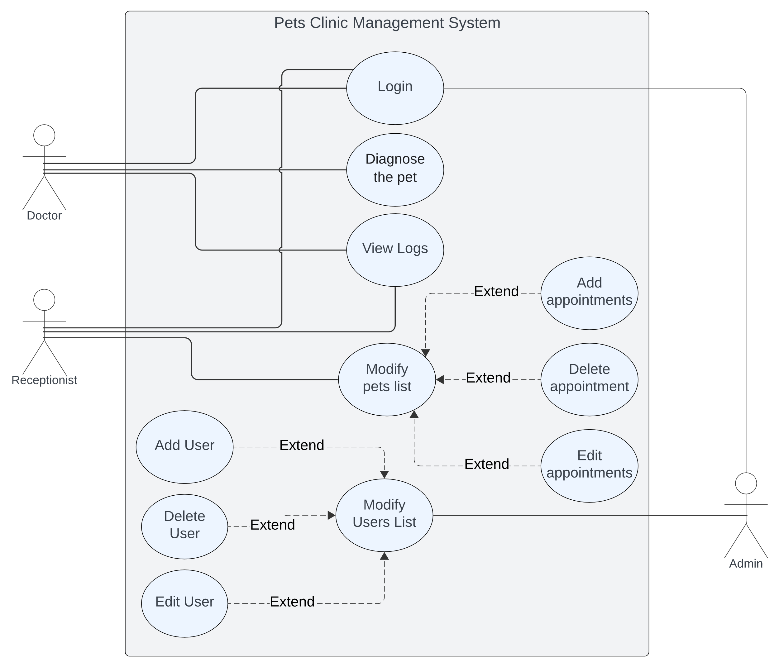

# ACTIVITY DIGRAM

# STATE DIAGRAM

# CLASS DIAGRAM

# Sequence diagrams

* Admin sequence diagram

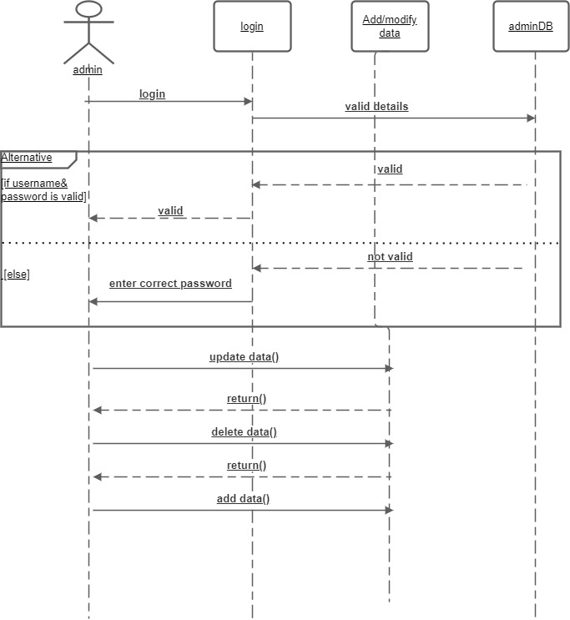

* Patient sequence diagram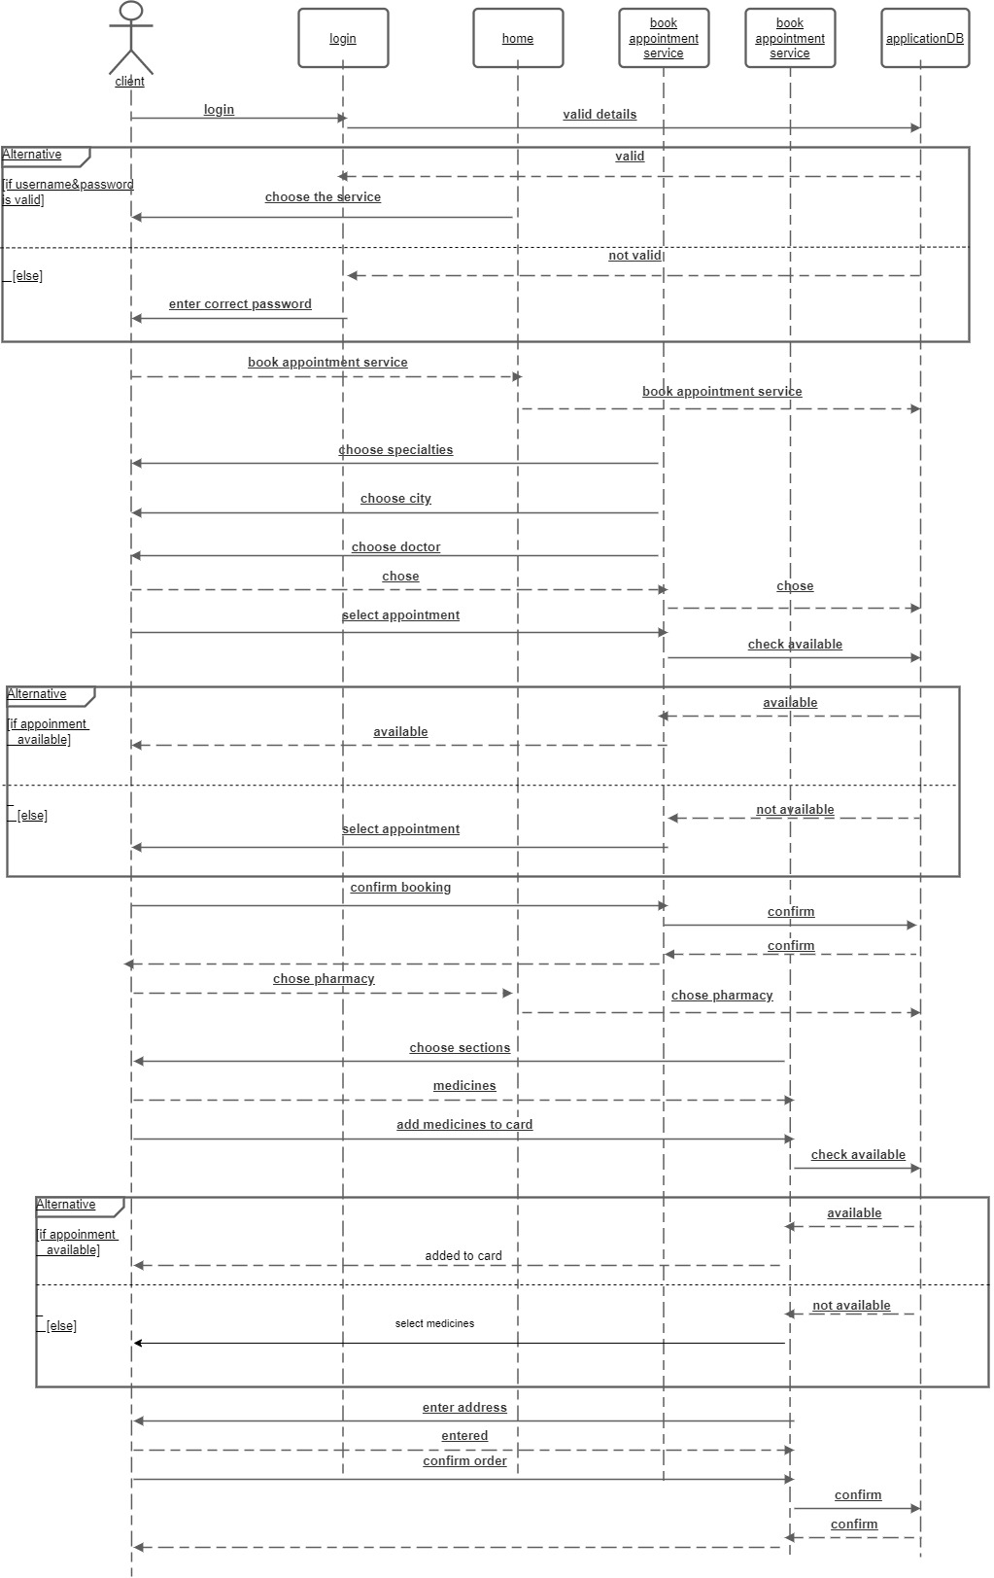
* Doctor sequence diagram

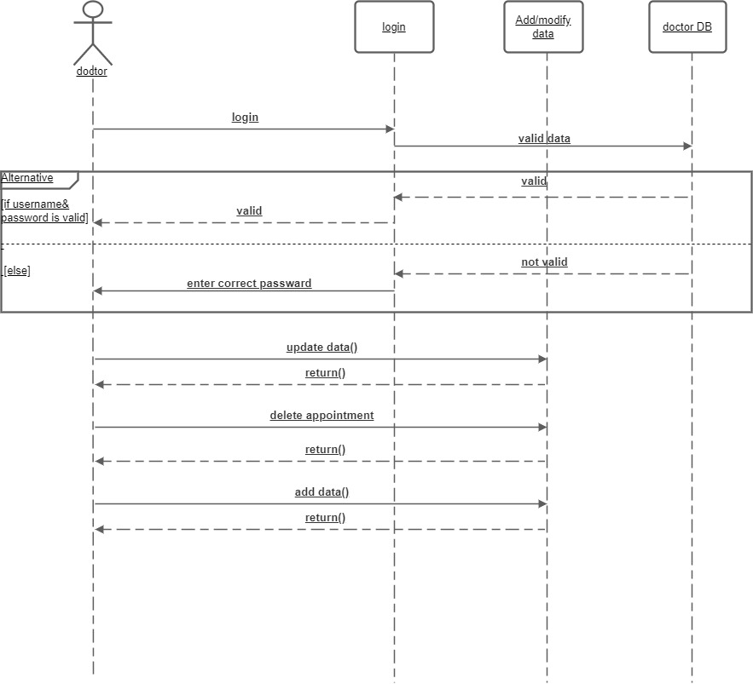

# Dataflow diagram (DFD)

* DFD level 0Diagram

  Description automatically generated
* DFD level 1

* Diagram

  Description automatically generatedDFD level1 continued
* Diagram

  Description automatically generatedDFD LEVEL 1 CONTINUED 2

# System graphic user interface

* Register frame

* Login frame

* Home frame

* Chose doctor frame

* Pharmacy

# Conclusion: -

At the we hope the clinic management system have been provide better and easier experiment for the patient in process of booking appointment